Project 1
Importing a JSON Land Value Dataset Into ArcGIS Using a Python Toolbox

1. Introduction
The 2018 New Orleans Land Value dataset, retrieved from data.gov, is distributed in JSON format and contains parcel geometries encoded as Well-Known Text (WKT). Although WKT is a recognized vector geometry standard, ArcGIS cannot directly import it using the Tools in Toolboxes (such as JSON to Feature).
In response, this project develops a complete workflow that programmatically extracts metadata and spatial features from the JSON file, converts WKT geometries into ArcPy polygon objects, and writes the results to a shapefile. A Python Toolbox (.pyt) is subsequently implemented to provide a reusable graphical interface within ArcGIS Pro. Finally, the resulting shapefile is visualized in a map layout, completing the full geospatial data preparation process.
This report follows the structure outlined in the instructor’s Guided Project 1 instructions, including code testing in a Jupyter notebook, interface design, data visualization, and final documentation.

2. Data Description
The dataset used in this project is stored as no_tax.json, which contains 496 parcel features. The JSON file has two primary structural components "meta" and "data". “Meta" includes descrpitons of fields. "Data" includes geometries and field value.
The example of meta:
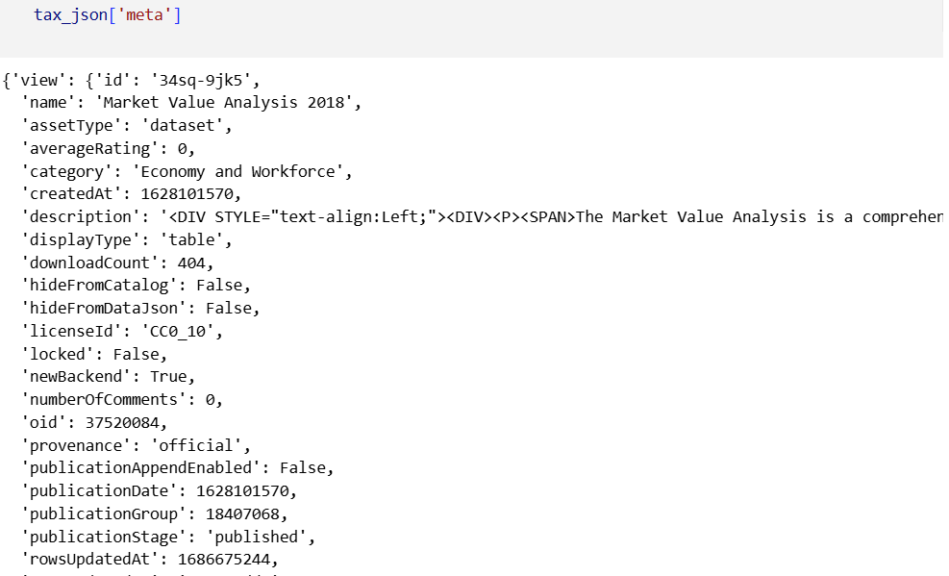

The sample of data:
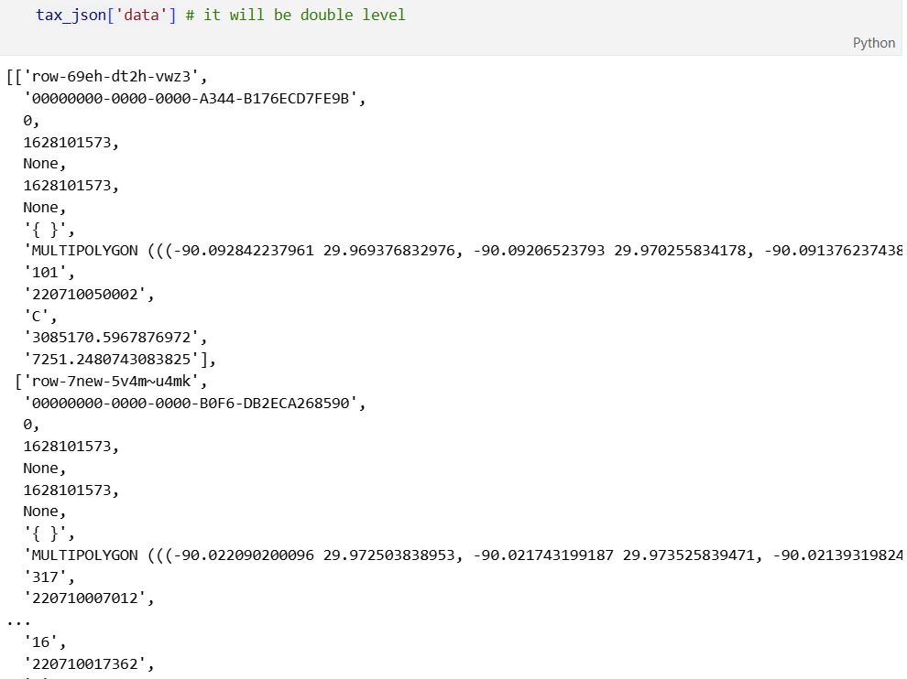

3. Jupyter Notebook Code Development
The core logic for converting the JSON dataset into a shapefile was developed and validated in a Jupyter Notebook before being formalized into a standalone Python script. The final script contains a structured workflow that performs JSON parsing, WKT geometry conversion, feature class creation, and attribute writing.
3.1. Parsing the JSON File
Reading the file using Python’s built-in json library.
The line imports the json module, which is a built-in Python library. The json module lets you read (load) JSON data from files/strings and write (dump) Python objects back to JSON.
open('data/no_tax.json', 'r'): Tells Python to open the file named no_tax.json inside the folder data. 'r' means read mode (you’re only reading, not writing). So, This line is open the file no_tax.json for reading and call it file.
json.load(file) reads the content of the open file (file) and parses the JSON text. It converts the JSON into normal Python objects (usually a dict at the top level, with lists and other dicts inside). The result is stored in the variable tax_json.
3.2. Converting WKT Geometries into ArcPy Polygon Objects
The JSON dataset stores parcel geometries in Well-Known Text (WKT) format, which must be converted into ArcPy geometry objects before they can be written into a shapefile. The following code segment performs this conversion:
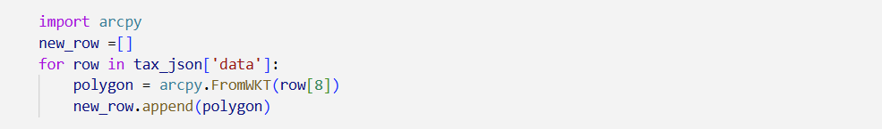
import arcpy: the arcpy module provides access to ArcGIS geoprocessing functions, including geometry constructors such as FromWKT.
new_row = []: creates an empty list that will store all converted geometry objects.
for row in tax_json['data']: processes each entry in the "data" section of the JSON structure. Each row is a list containing attribute values followed by the WKT geometry string.
polygon = arcpy.FromWKT(row[8]): reads the WKT string located at index 8 of each row (the known position of the geometry field) and converts it into an ArcPy Polygon object.
new_row.append(polygon): adds each resulting polygon to the new_row list, preserving order for later insertion into the feature class.
3.3. Creating the Output Feature Class
Before writing attribute and geometry data, an empty feature class must be created to serve as the destination for the converted records. The following code prepares the output workspace, handles file overwriting, and initializes the shapefile structure:
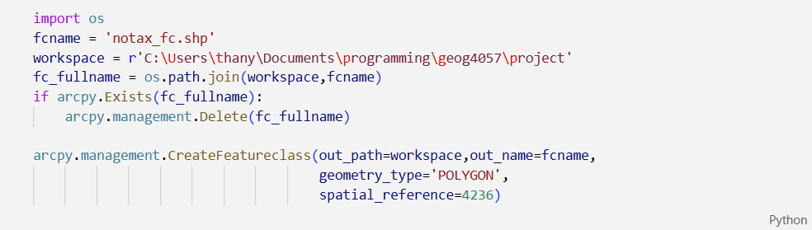
This segment performs several key functions. First, the os module constructs a valid file path for the output shapefile. The script then checks whether a file with the same name already exists in the workspace; if so, it is deleted to avoid conflicts during creation. The CreateFeatureclass function generates a new empty polygon feature class with spatial reference EPSG 4236, matching the coordinate system of the input dataset. This output feature class provides the structural foundation for adding fields and inserting the converted polygon geometries.

3.4. Generating Attribute Fields from JSON Metadata
Attribute fields are created dynamically based on the metadata provided in the JSON file:
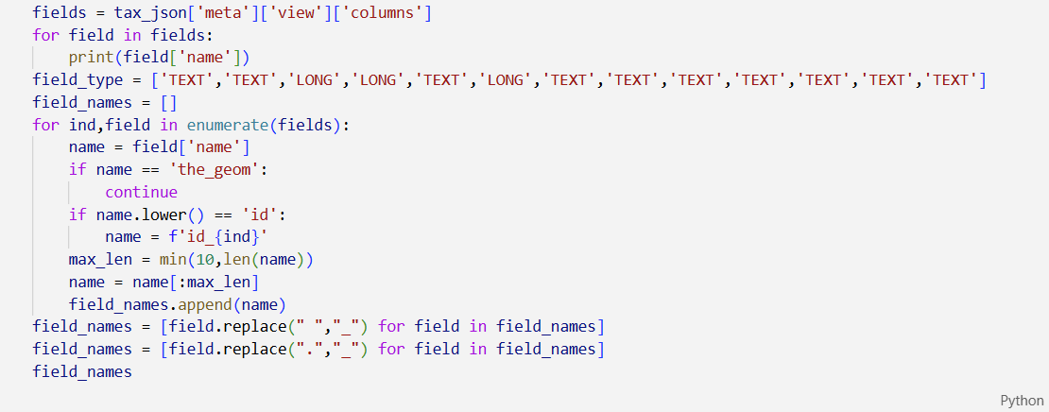
The notebook accessed the JSON metadata through the "meta" → "view" → "columns" structure, which contains a list of field descriptors corresponding to the attributes associated with each parcel record. For every field in this list, the script extracted the field name and prepared it for use in a shapefile, applying several transformations to ensure compliance with ArcGIS field-naming constraints.
Because shapefiles enforce a maximum field name length of ten characters and prohibit spaces and special characters, the script truncated field names to ten characters and replaced any spaces or periods with underscores. In addition, the "the_geom" field, representing the original WKT geometry, was intentionally skipped because its content is handled separately through ArcPy geometry objects. The script also addressed the presence of multiple fields named "id" in the dataset by appending the field index to each duplicate, creating unique names such as id_1 or id_10.
Once the cleaned and validated field names were finalized, each attribute field was added to the feature class using arcpy.management.AddField(image below), with field types determined by a predefined list that matched the expected data types from the JSON structure. This automated field-generation process ensured that the resulting shapefile preserved the complete attribute structure of the original dataset while meeting all technical restrictions of the shapefile format.
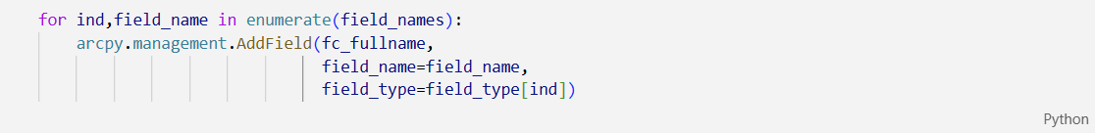

3.5. Inserting Attribute and Geometry Records
Once the schema and geometry objects are prepared, the script populates the feature class using an InsertCursor:
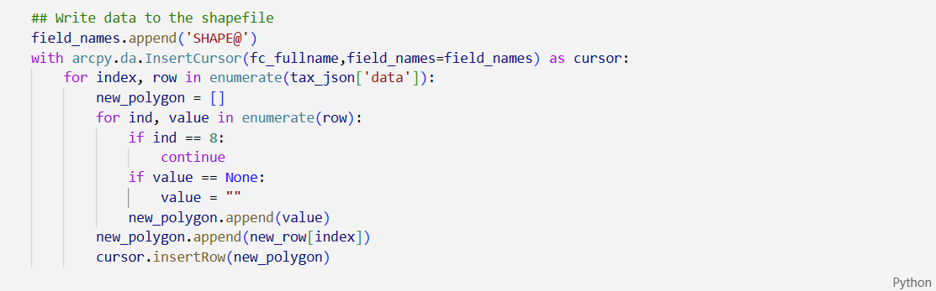
The insertion process performs the following tasks: Ignores the WKT column, which has already been converted into polygon objects. Replaces null values with empty strings to avoid insertion errors. Appends the correct polygon geometry for each record. Inserts the finalized row into the shapefile. By the end of this stage, all attribute fields and geometries from the JSON dataset have been transferred into the shapefile, completing the data conversion workflow.
3.6. Summary
The notebook implements a robust data-conversion pipeline that transforms a JSON dataset with WKT geometries into a structured and spatially meaningful shapefile. Each stage from loading metadata, parsing geometry, creating the feature class, generating attribute fields, and finally inserting the complete records works together to replicate the full JSON dataset within an ArcGIS compliant environment. This workflow served as the foundation for developing the Python Toolbox version of the tool.

4. Transition from Jupyter Notebook to Python Script
The Jupyter Notebook served as the initial environment for exploratory development, allowing each step of the JSON to shapefile workflow to be tested interactively. While this environment was effective for prototyping, several components in the notebook relied on hard-coded values, temporary variables, and manually executed cells. These characteristics, although acceptable during development, prevented the workflow from being reusable, modular, or suitable for integration into an ArcGIS Python Toolbox.
In the notebook, key elements such as the input file path, output workspace, field index for the WKT geometry, and spatial reference were explicitly hard-coded within individual cells. Similarly, field-name cleaning rules, cursor insert operations, and geometry conversion loops were written in a linear, cell-dependent format. This structure made the notebook highly dependent on execution order and user interaction. To transform the workflow into a robust, standalone tool, these hard-coded elements needed to be replaced with parameter-driven logic and encapsulated inside functions.
The transition to the Python script involved systematically refactoring these components. The JSON file path, workspace directory, and output feature class name were converted from fixed values into parameters within the json2shape() function and ultimately the main() function. Hard-coded field indices were abstracted and documented to ensure maintainability. The creation of the spatial reference, previously embedded as a literal numeric code, was formalized into a configurable argument. Additionally, all steps including JSON loading, WKT conversion, field generation, and cursor insertion—were reorganized into a sequential, reusable workflow within a single function. Temporary print statements and debugging artifacts from the notebook were removed to ensure a clean execution environment.
By restructuring the notebook code into a parameterized .py file, the workflow became generalizable, reproducible, and suitable for automation. The script no longer depends on manual cell execution or local hard-coded values; instead, it operates as a standalone geoprocessing component ready for integration into the ArcGIS Python Toolbox. This transformation represents a critical evolution from exploratory development to a fully functional and deployable spatial data processing tool.

Table 1 Hard-coded Elements in the Notebook and Their Replacements in the Python Script
Hard-coded Element in Jupyter Notebook | Issue / Limitation | Improved Implementation in .py Script | Benefit
Fixed JSON file path (e.g., "data/no_tax.json") | Only works for this exact file; cannot reuse | Converted into a function parameter (input_json) | Allows user to select any JSON file
Hard-coded workspace directory | Prevents saving output to other locations | Replaced with a parameter (workspace) | User controls output folder
Hard-coded shapefile name (notax_fc.shp) | Not flexible; overwrites same file | Replaced with parameter (fcname) | Allows custom output naming
Hard-coded geometry column index (row[8]) | Assumes geometry always at index 8 | Encapsulated and documented in conversion function | Easier to modify if dataset changes
Hard-coded spatial reference (4236) | No control over coordinate system | Passed as argument (wkid) | Supports multiple spatial references
Field-name truncation and cleaning scattered in cells | Repetitive and difficult to maintain | Consolidated into a reusable field-cleaning loop | Cleaner code, easier maintenance
Temporary debug prints (e.g., print(field.name)) | Not suitable for production | Removed or put # | Professional, streamlined output
Manual execution of cell blocks | Workflow depends on user interaction | Converted into sequential functions (json2shape() and main()) | Fully automated execution
Notebook-only variables not reused outside cells | Fragile and context dependent | Organized into local function variables | Predictable and reproducible
WKT conversion loop embedded in cell | Difficult to reuse | Encapsulated into geometry conversion logic inside function | Modular and clear design

5. Python Toolbox Development
A Python Toolbox (.pyt) was created to make the JSON-to-shapefile workflow accessible through the ArcGIS Pro interface.
5.1. Toolbox Structure
The toolbox contains two classes:
Toolbox – defines the toolbox name, alias, and tool list
Tool – defines the interface, parameters, and execution logic
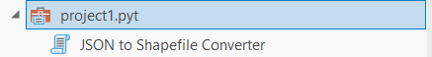
User inputs are handled through getParameterInfo(), which defines:
Input JSON file
Output workspace
Output shapefile name
Optional spatial reference (WKID)
These parameters replace the hard-coded paths used during notebook development.
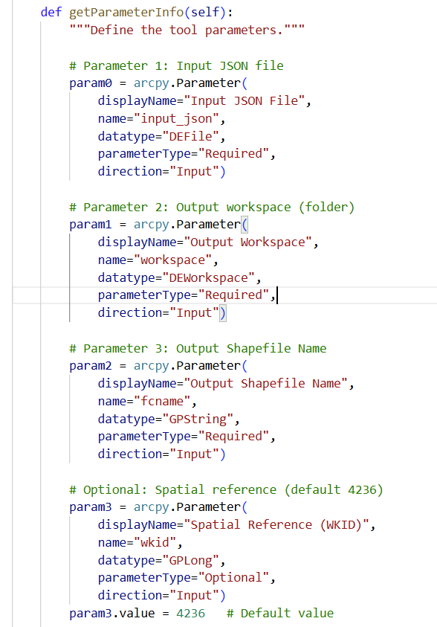
5.2 Execution Logic
The execute() method retrieves user-defined inputs and passes them to the json2shape() function. All processing, JSON parsing, WKT conversion, field creation, and feature insertion occurs within the script, while ArcGIS Pro manages the interface and messaging.
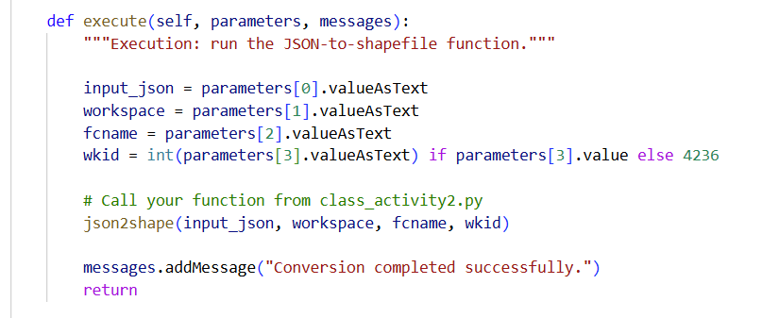

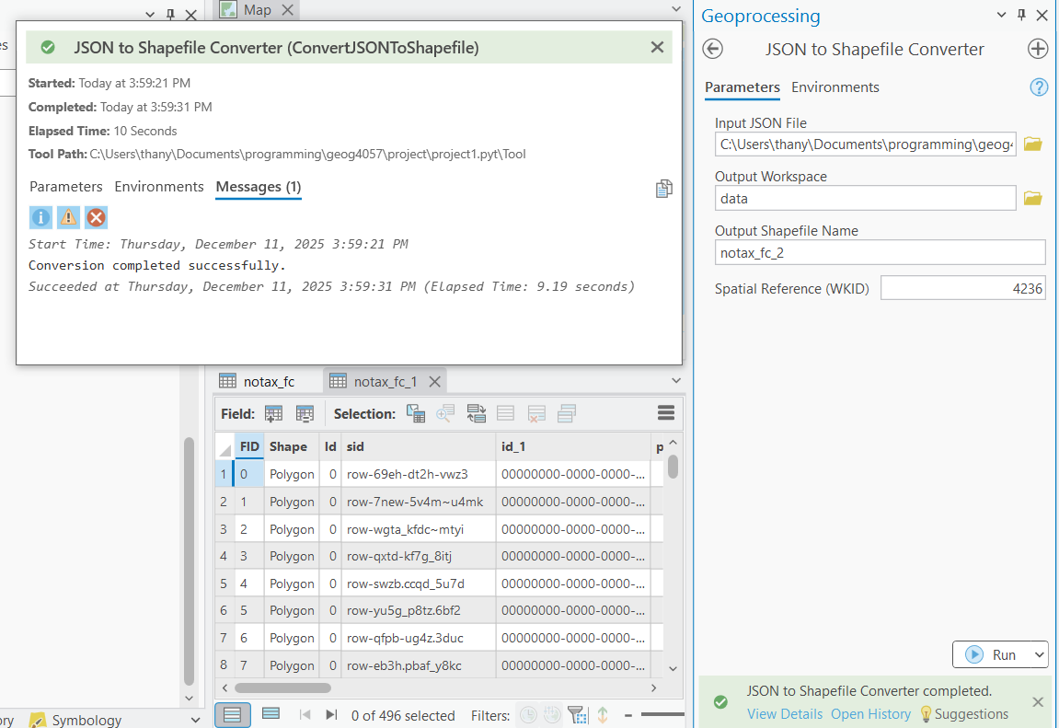

6. Data Visualization
After generating the shapefile using the Python Toolbox, the resulting polygon layer was added to an ArcGIS Pro map for visualization and verification. This step confirms that the geometry conversion and attribute construction were performed correctly. Output parcel polygons is showed below:
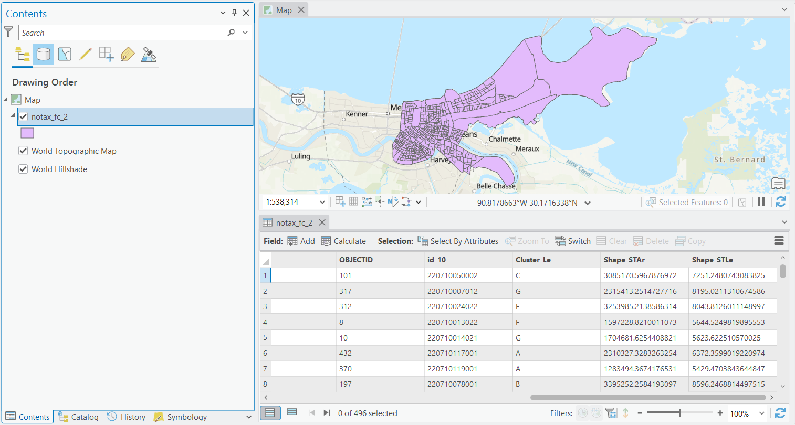
The layer’s symbology was modified to enhance visual interpretation. Several attribute fields generated from the JSON metadata can be used for styling, for example:
- Unique values for cluster categories
- Graduated colors for area or other numeric attributes
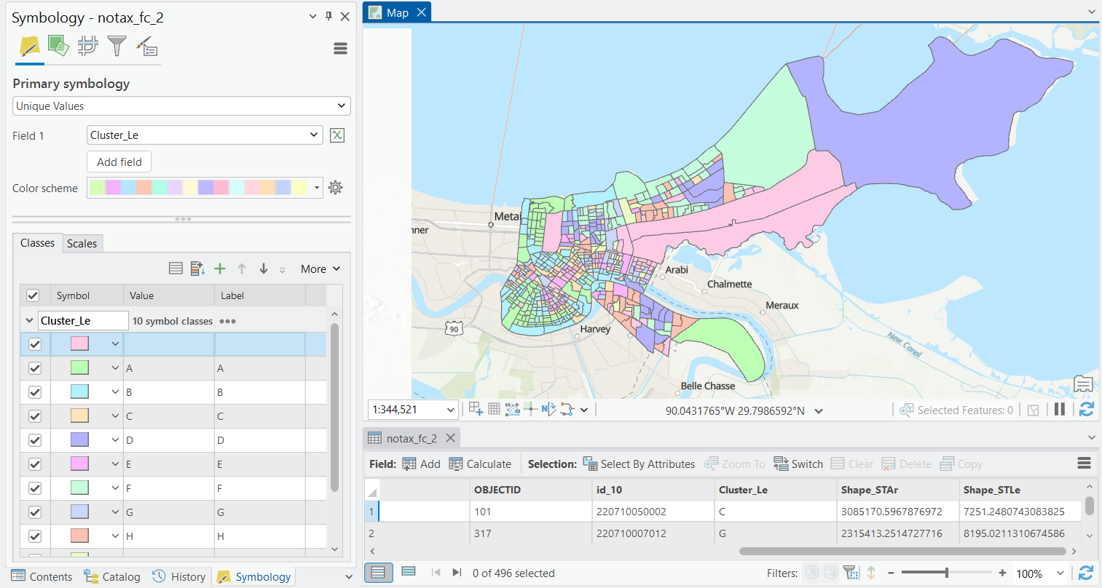
6.1. Making the layout using python
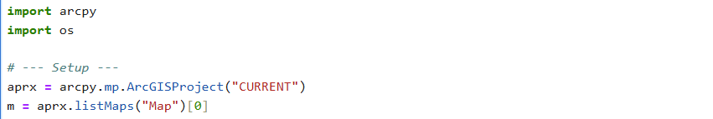
This code initializes access to the currently open ArcGIS Pro project using ArcGISProject("CURRENT"). The target map is retrieved by name, enabling Python to interact directly with the active GIS environment. All subsequent operations, including data loading and layout creation, depend on this project and map reference.
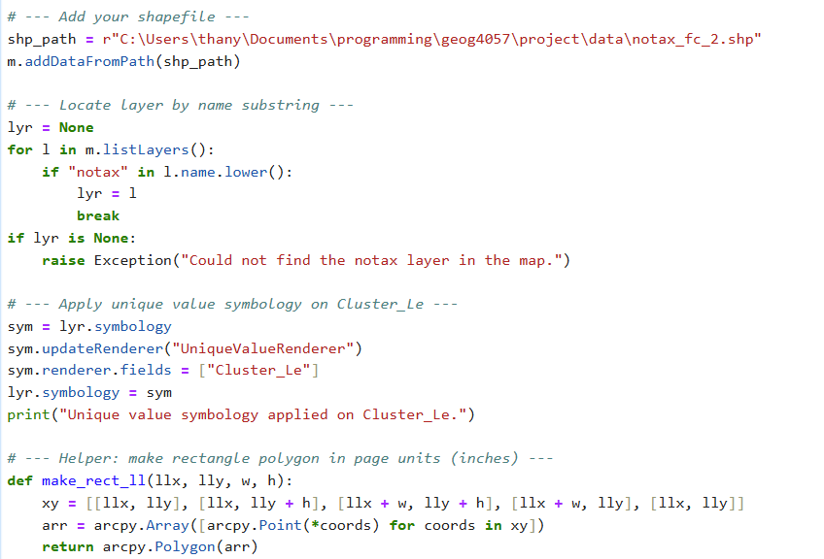
The output shapefile generated from the JSON processing step is added to the map programmatically. This ensures that the dataset is available for visualization and eliminates the need for manual data loading in the ArcGIS Pro interface.

This block searches through all map layers and identifies the target layer based on a name substring. This dynamic approach avoids hard-coding layer names and improves the reusability of the script across different projects or datasets.
Unique values symbology is applied using the Cluster_Le attribute. This categorizes parcel features into distinct clusters and assigns a different symbol to each group, enabling visual interpretation of spatial patterns within the dataset.

This helper function constructs rectangular polygon geometries using page units (inches). These polygons are used to precisely control the size and placement of layout elements such as the map frame and scale bar.
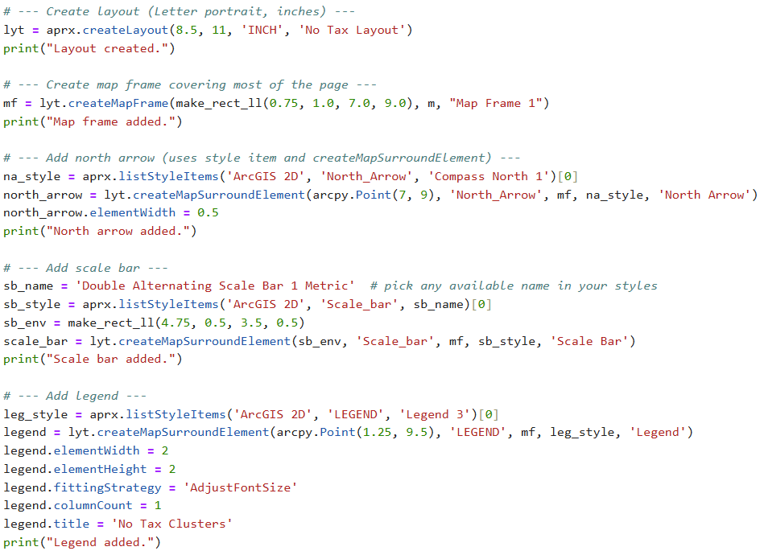
A new layout is created with letter-size dimensions (8.5 × 11 inches). Defining the layout programmatically ensures consistent formatting and prepares the workspace for automated cartographic element placement.
The map frame is created using a rectangular geometry that specifies its position and size on the layout. The map frame links the spatial data in the map to the layout, allowing the clustered parcels to be displayed in the final map.
A north arrow is added using a predefined ArcGIS Pro style item. This element provides map orientation and enhances cartographic readability.
A scale bar is added to provide spatial reference. The element is positioned using a rectangular geometry and styled using built-in ArcGIS Pro cartographic templates.
The legend is generated automatically from the map symbology and formatted to improve readability. It clearly explains the meaning of the Cluster_Le categories shown in the map.
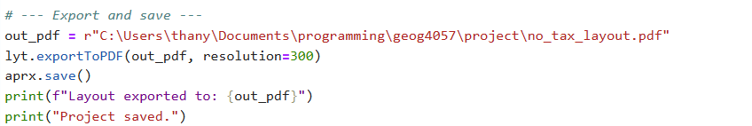
The completed layout is exported as a PDF file. The project is then saved to preserve all automated layout and symbology changes. The final product showed below:
